**Expected (average) % of shared atDNA with family members**

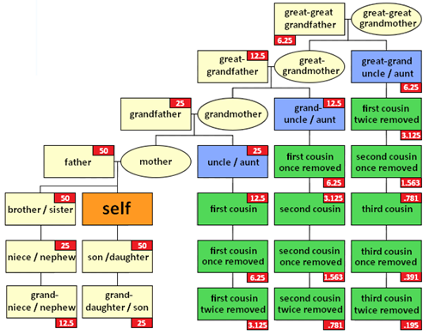

|  |  |
| --- | --- |
|  |  |

**IBD** = Inherited by descent. **IBS** = false positives

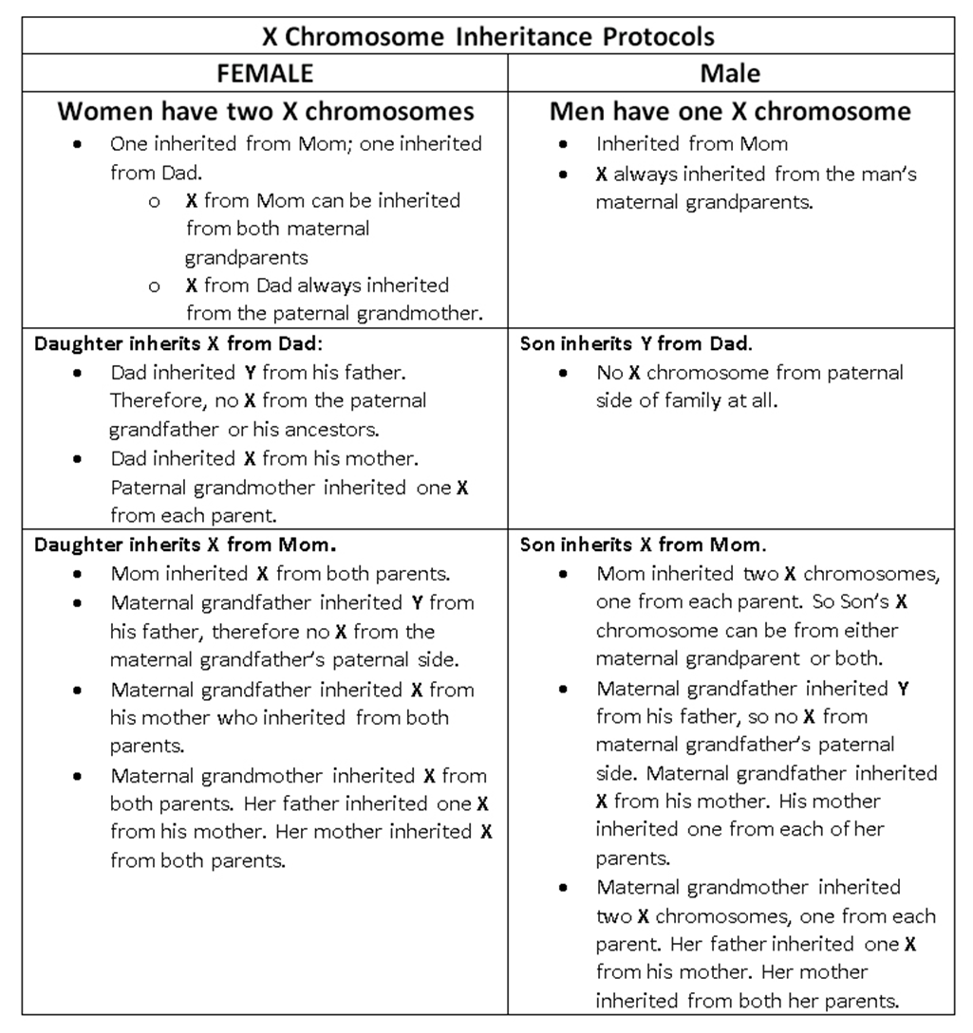

**Fathers cannot share xDNA with sons!**