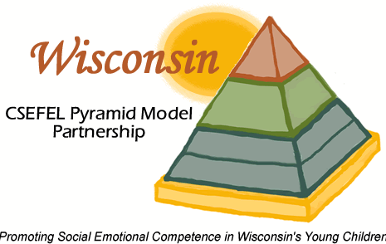**The Role of Birth to 3 in Supporting Pyramid Model Implementation**

**What is the Pyramid Model?**

The Pyramid Model is a tiered prevention and intervention model to prevent and address challenging behaviors and promote healthy social and emotional development in children birth to age 5 through evidence-based practices.

Implementation of the Pyramid Model has the greatest impact on child outcomes when systematically implemented across a program that serves young children and their families. Program wide implementation involves these key elements:

* A program leadership team
* Staff buy- in
* Program wide expecations
* Family participation
* Coaching for or to teachers to support implementation
* Data based decision making
* Behavior support procedures

**What is your role as Birth to 3 staff?**

Being knowledgeable in the tiered practices of the Pyramid Model and supporting those programs that serve infants, toddlers and their families in the Pyramid Model implementation by:

* Attending Pyramid Model training and providing support to other Birth to 3 staff and county colleagues in understanding evidence-based Pyramid Model practices.
* Assist in developing Pyramid Model practices while supporting children and families within natural environments.
* Encouraging teachers and administrators to learn more about progam wide Pyramid Model implementation
* Serving as a member- either directly, or as an advisory member- on a program leadership team to guide and support development of an infrastructure (e.g., professional development, procedures and policies ) to implement all tiers of the Pyramid Model.
* Supporting internal coaches to assist, support, and help program teachers in the practices of the Pyramid Model, including universal practices designed to promote optimal social emotional development in all children.
* Providing supplemental training or coaching to assist teachers in implementing Pyramid Model practices and procedures as part of individualized professional development action plans.
* Assisting in the development and implemention of procedures to address the individual needs of children by guiding the functional behavior assessment process or by connecting program staff with community resources.